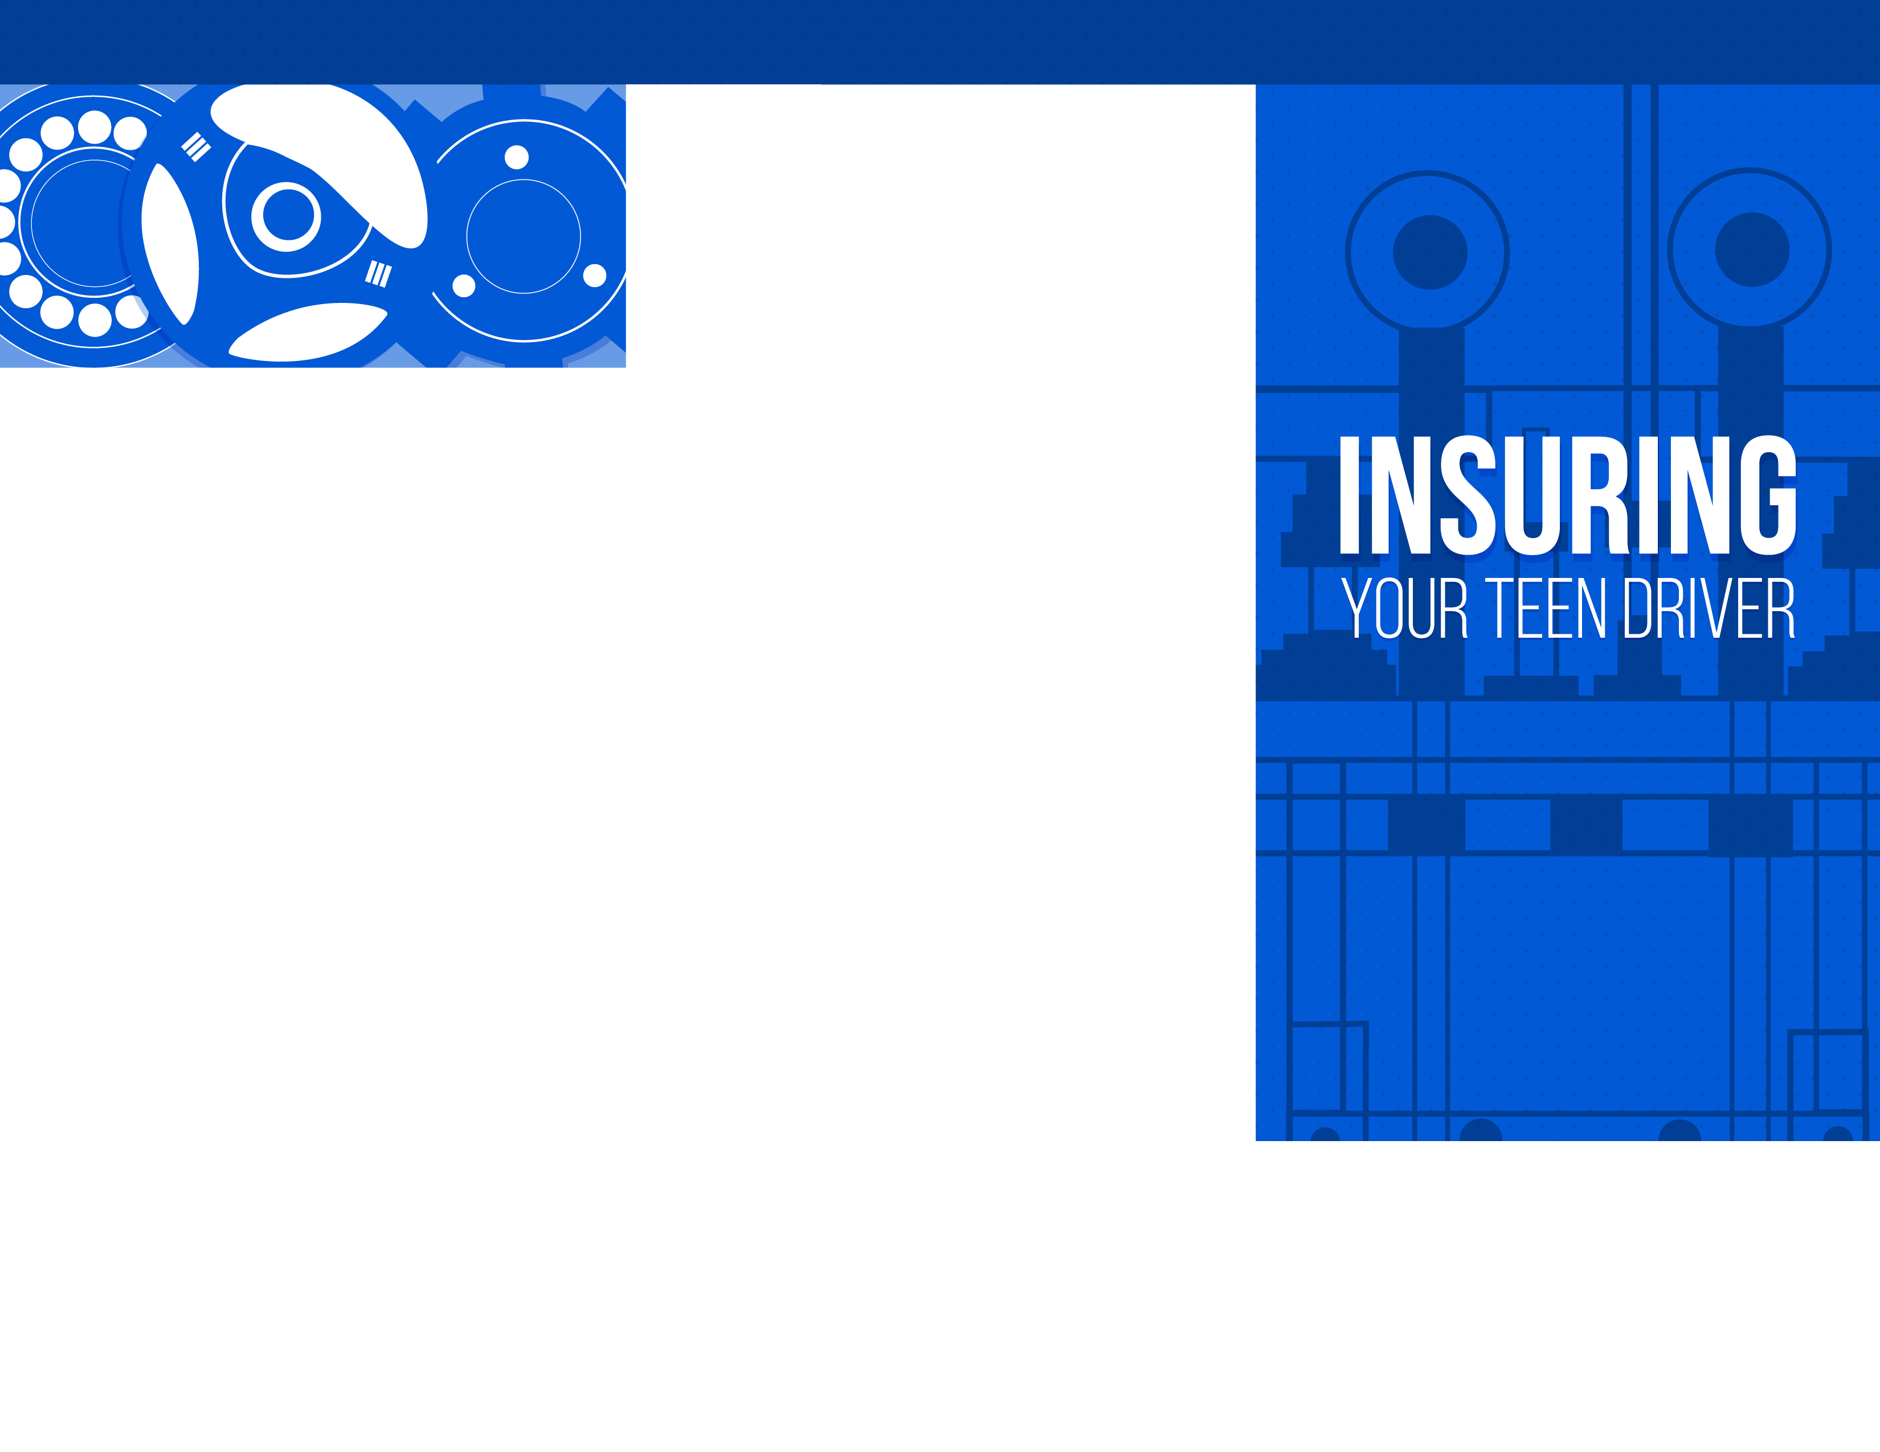

Eaton Insurance Services
11436 N. Linden Road
Clio, MI
48420
Tel: 810-686-1470
http://www.eatoninsuranceservices.com/
Insuring a new driver can be expensive. Learn what you can do to keep your premiums as low as possible and your teen accident-free.
Top Ways to Save on your Auto Premium
- Consider raising your deductible
- Ask about a good student discount
- Have your teen keep up their good driving record
- Enroll your teen in driver’s education
- Ask about our multi-policy discounts

Minimize Distracted Driving
While you can’t do anything about your teen’s young driver status, there are many things you can do to help them keep their good driver standing. Teens get distracted easily, which increases their risk. To minimize their potential for distractions:
- Do not allow them to drive with more than one other person in the car for the first year of driving
- Ban the use of electronics, such as talking or texting on a cell phone or listening to music, while behind the wheel


Set Your Expectations for Safety
The best way to keep your teen’s insurance premium stable is for them to keep their driving record clean. To help reduce potential accidents:
- Restrict your teen’s nighttime driving
- Limit the number of passengers in the vehicle
- Ban cell phone use while driving
- Establish driving-area limits
- Set a curfew
- Talk to your teenager about the dangers of drinking and driving
- Insist on seat belt use for everyone in the vehicle
- Ride with your son or daughter occasionally to make sure they are keeping up with the safety habits that they learned in driver’s education

We’re Here to Help
To find out more about our auto coverages solutions and adding a teen driver to your auto insurance policy, please contact us at 810-686-1470.

Disclaimer: This brochure is provided for informational purposes only. The information provided herein is not intended to be exhaustive, nor should it be construed as advice regarding coverage. Eligibility for coverage is not guaranteed and all coverages are limited to the terms and conditions contained in the applicable policy. © 2008, 2016 Zywave, Inc. All rights reserved.

The Basics of Insuring Your Teen Driver
If you’re the parent of a teenager who is getting ready to climb behind the steering wheel, insuring them can be an expensive endeavor. This is because the risk of motor vehicle crashes is higher among 16- to 19-year-olds than among any other age group. We’ve gathered some helpful tips to help you keep your premiums as low as possible, and your teen safe and accident-free.

Policy Options
Rather than setting up an independent policy for your teen driver, consider adding them as an additional driver on your Auto insurance policy. Typically, this is most cost-effective option. Also, if you have more than one vehicle, designate which vehicle your child will be driving. The newer the car, the more expensive the coverage will be.

Deductible Considerations
Auto deductibles typically range from $250 to $1,000. By upping your deductible and utilizing your insurance for big repairs, you can significantly reduce your premium. If you lease or finance a car, the leasing or financing company may require a deductible cap of $500.

Enroll Your Teen in Driver’s Education
Although courses may be available at your child’s school, consider enrolling him/her in a driver’s education course. Often, discounts are available for teens who take recognized driving classes because it extends the teaching period.

Weigh Your Buying Decision
Wanting to get your teenager a new car to drive with the latest safety equipment is understandable, but you may be better off purchasing a safe, used vehicle. Before you make an auto purchase, we’d be happy to give you an insurance quote to help you with your buying decision.

